Information for 왕초보 English

Introduction
Many people in Korea are learning English, but many are afraid to try speaking it! This course is designed to make you feel more comfortable and confident speaking English. It will also give you an opportunity to communicate in English and to learn English pronunciation.

Purpose of the Course
1. To improve your English skills in speaking and listening based on topics in the textbook.
2. To increase your ability to use important English vocabulary.
3. To improve your grammar knowledge to make proper English sentences.
4. To help you gain confidence in speaking English.

Learning Outcomes
1. You can understand what native speakers say in basic conversation.
2. You can acquire vocabulary related to topics in the textbook.
3. You can acquire important structures(grammar) to speak English properly.
4. You can meet foreigners with confidence.

Class Preparation & Homework
Spend as much time as you can prepare and review for class. Find meanings of new vocabulary before class. Memorize new words and expressions you study every day and study handouts(homework). If you practice every day, you will see a big difference in how quickly you learn!

Course Outline
The course contains fifteen units of the text book and lots of handouts. There will be a lot of interesting activities (grammar & communication practice, songs, speeches, games etc.).

Attendance
If you would like to pass this class, you must attend at least 10 classes out of 12 classes. If you attend all classes, you can improve your English conversation skills effectively.

Evaluation
This class is not graded, but is pass/fail. You will pass this course if you participate in all activities in class. There will be a five-minute speech, a final interview, songs and games.

Tip
Relax! Don’t worry about your mistakes in speaking English. We will all work together to help fix our mistakes. Let’s have fun with me!
Syllabus for 왕초보
Day | Textbook | Activities
1 | Course Introduction  Unit 1 It’s nice to meet you | Self-introduction, My ability  Pronunciation 1  Vocabulary 1 / Review 1
2 | Unit 2 What’s this? | Name Game / Pronunciation 2  Vocabulary 2 / Review 2
3 | Unit 3 Where are you from? | Vocabulary 3 / Review 3  English Song 1& Pronunciation 3
4 | Unit 4 I’m not wearing boots  Unit 5 What are you doing? | Vocabulary 4/5 / Review 4/5  Bingo game / Pronunciation 4
5 | Unit 6 My sister works downtown. | Vocabulary 6 / Review 6  Speech 1 / Pronunciation 5
6 | Unit 7 Does it have a view? | Vocabulary 7 / Review 7  Seed Quiz / Pronunciation 6
7 | Unit 8 What do you do? | Vocabulary 8 / Review 8  Speech 2 / Pronunciation 7
8 | Unit 9 Broccoli is good for you. | Vocabulary 9 / Review 9  Pronunciation 8 / Crossword Puzzle 1
9 | Unit 10 I can’t ice-skate very well.  Unit 11 What are you going to do? | Vocabulary 10/11 / Review 10/11  Pronunciation 9 / Speech 3
10 | Unit 13 You can’t miss it. | Vocabulary13 / Review 13  English Song 2 / Pronunciation 10
11 | Unit 14 Did you have fun? | Vocabulary 14 / Review 14  Speech 4 / Pronunciation 11
12 | Unit 15 Where were you born?  Interview Test & Party | Vocabulary 15 / Review 15  Pronunciation 12 / Crossword Puzzle 2
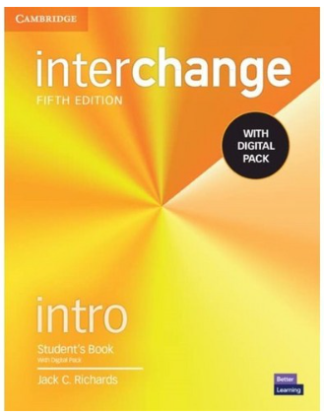
Text book
Interchange Intro (5th edition) SB
(Student Book with Digital Pack)
–Cambridge University Press

