Journey to Effective English Communication

English Conversation Class—Intensive 1

Russell Kirkby
russell_kirkby@hotmail.com
KakaoTalk ID: RussellKirkby

Overview
The purpose of this course is to help you improve your overall English skills, especially your ability to speak. To achieve this, you will be given many opportunities to converse with your classmates and the instructor, a native English speaker from the United Kingdom (more specifically, England). By attending regularly and by participating enthusiastically in the class, you will most likely develop your fluency skills, build a stronger vocabulary, become a better listener, and learn some basic grammar. In this context, fluency refers to the speed and rhythm of your speech, and building a stronger vocabulary refers to learning new words and expressions. Ultimately, communicating effectively is the main goal; you do not need to use perfect English (grammar) to achieve this! As mentioned above, there is a lot of interaction in every class (talking to other students [and the instructor]); therefore, if you enjoy being sociable and communicating with others, you will hopefully have a lot of fun as well as improve your command of English!


There is no set textbook for this course. We will likely use material from various sources and the website breakingnewsenglish.com, a free educational website that provides ready-made English language lessons based on current news stories. Additional class materials will also be used throughout the 6-week course.

There are five classes per week (Monday to Friday), each lasting 50 minutes.

Class Content
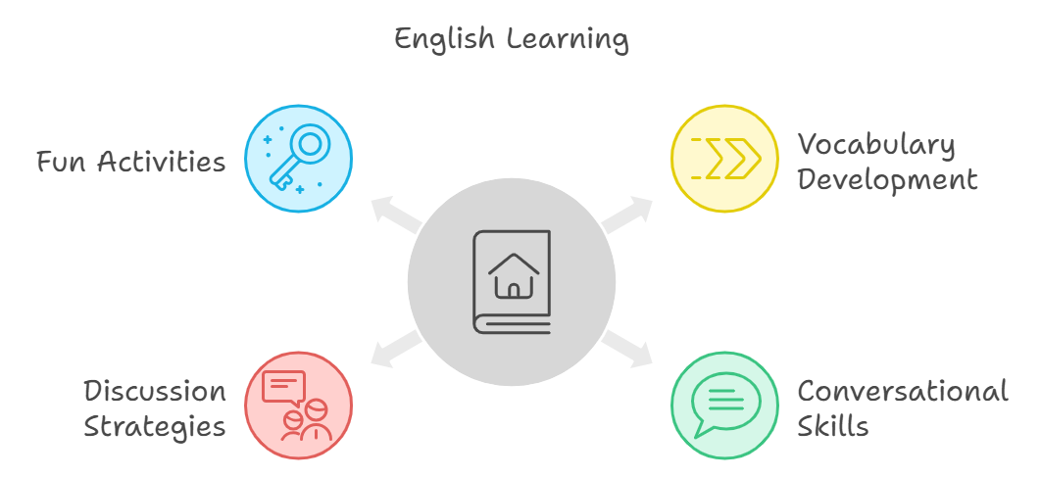
During classes, with Russell’s help, you will:
analyze example dialogues to learn colloquial vocabulary and expressions;
read short news articles to expand your general and academic vocabulary;
engage in conversations based on the class materials and topics;
share your opinions on topics and practice agreeing/disagreeing with classmates through mini-debates;
learn conversation strategies to help you converse more effectively and naturally in English.

Please contact me by email at the address above or by using KakaoTalk if you have any questions :)

