Information for Starter 1
Introduction
Many people in Korea are learning English, but many are afraid to try speaking it! This course is designed to make you feel more comfortable and confident speaking English. It will also give you an opportunity to practice communicating with a teacher and classmates in English.

Purpose of the Course
1. To improve your English skills in speaking and listening based on topics in the textbook.
2. To increase your ability to use important English vocabulary.
3. To improve your grammar knowledge to make proper English sentences.
4. To help you gain confidence in speaking English.

Learning Outcomes
1. You can communicate with a native speaker in simple conversation.
2. You can acquire vocabulary related to topics in the textbook.
3. You can acquire important structures(grammar) to speak English properly.
4. You can meet foreigners with confidence.

Class Preparation & Homework
Spend as much time as you can prepare and review for class. Find meanings of new vocabulary before class. Memorize new words and expressions you study every day and study handouts(homework). If you practice every day, you will see a big difference in how quickly you learn!

Course Outline
The course contains eleven units of the text book and lots of handouts. There will be a lot of interesting activities (grammar & communication practice, songs, speeches, DVD, games etc.).

Attendance
If you would like to pass this class, you must attend at least 10 classes out of 12 classes. If you attend all classes, you can improve your English skills effectively.

Evaluation
This class is not graded, but is pass/fail. You will pass this course if you participate in all activities in class. There will be a five-minute speech, a final interview, songs and games.

Tip
Relax! Don’t worry about your mistakes in speaking English. We will all work together to help fix our mistakes. Let’s have fun with me!

Syllabus for Starter 1
Day | Textbook | Activities
1 | Course Introduction  Unit 1 People | Self-introduction, 5-Mnute Speech, My Ability  Review 1
2 | Unit 2 A Day in the Life | Today’s Expression 1/2  Countries & Nationalities / DVD Unit 1  Country Game / Name Game /Review 2
3 | Unit 3 Going Places | Today’s Expression 3/4  Occupation Quiz / Review 3  Travel Plans / English Song 1
4 | Unit 4 Food | Today’s Expression 5/6 /Review 4  Restaurant Conversation / DVD Unit 2
5 | Unit 5 Sports | Today’s Expression 7/8/ Review 5  Speech 1 / Sport Quiz
6 | Unit 6 Destinations | Today’s Expression 9/10 /Review 6  Irregular Verb Form/ Last Vacation / DVD Unit 4
7 | Unit 7 Communication | Today’s Expression 11/12  Speech 2 / Review 7
8 | Unit 8 Making Plans | Today’s Expression 13/14  My Future Plans / DVD Unit 5 / Review 8
9 | Unit 9 Types of Clothing | Today’s Expression 15/16 / English Song 2  Shopping Conversation / Speech 3/ Review 9
10 | Unit 10 Life Styles | Today’s Expression 17/18  DVD Unit 10 / My Lifestyle / Review 10
11 | Unit 11 Achievements | Today’s Expression 19/20 / Speech 4 / Review 11
12 | Review  Interview Test & Party | Tell me about 1
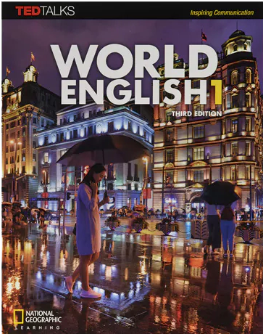
Text book
World English 1(3rd edition) Student’s Book
(with My World English Online)
– National Geographic Learning

